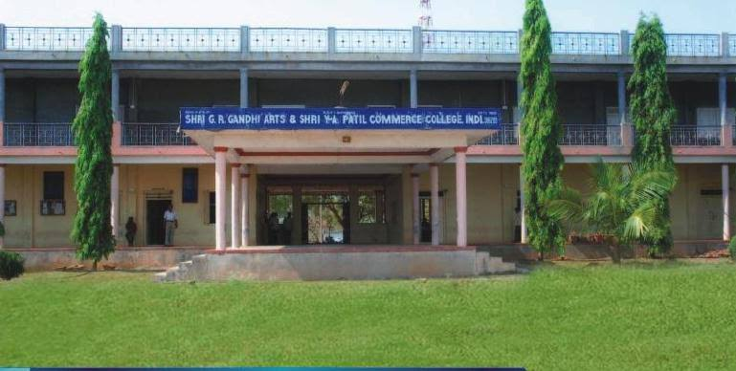
CRITERION VII - INSTITUTIONAL VALUES AND BEST PRACTICES
7.1.1 - Measures initiated by the Institution for the promotion of gender equity during the year
1. Annual gender sensitization action plan
2. Specific facilities provided for women in terms of:
A. Safety and security
B. Counseling
C. Common Rooms
D. Day care center for young children
E. Any other relevant information
7.1.1 - Measures initiated by the Institution for the promotion of gender equity during the year
The institution shows gender sensitivity in providing facilities for safety and security, Counseling and Common room as stated below.
A. Safety and security: The institution atmosphere is very safe to the girls and boys students. Security arrangements have been made in the college entrance gate, he closely monitors to enter students, staff and other visitors in the college. The institution has covered with 24×7 CCTV surveillance in the college premises, security monitor patrolling over the campus. Anti-ragging committee is also absolutely supervising the institution. 24×7 CCTV
SPECIFIC FACILITIES PROVIDED FOR WOMEN:
- SAFETY AND SECURITY:
SANITARY NAPKINS CCTV
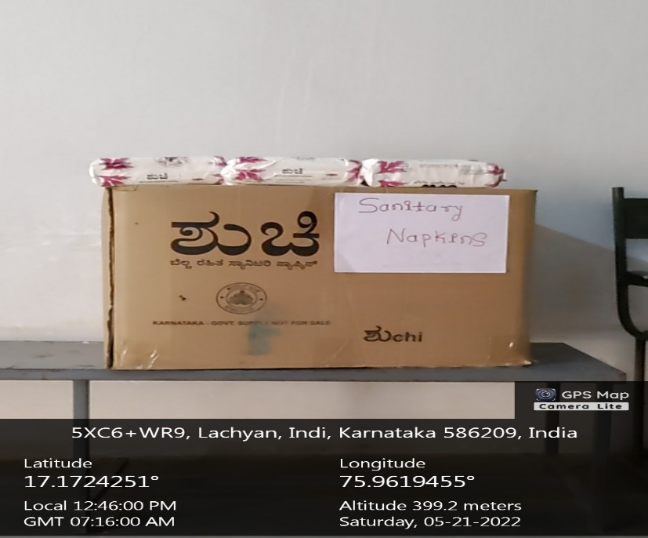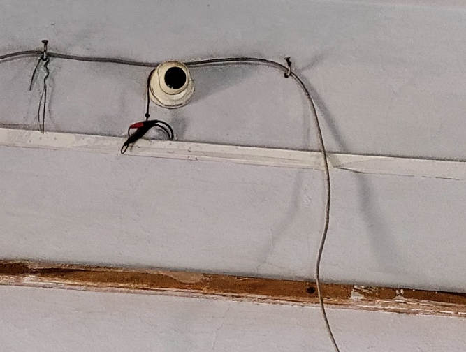
CCTV CCTV
FIRST AID BOX FIRE FIGHTING SYSTEM
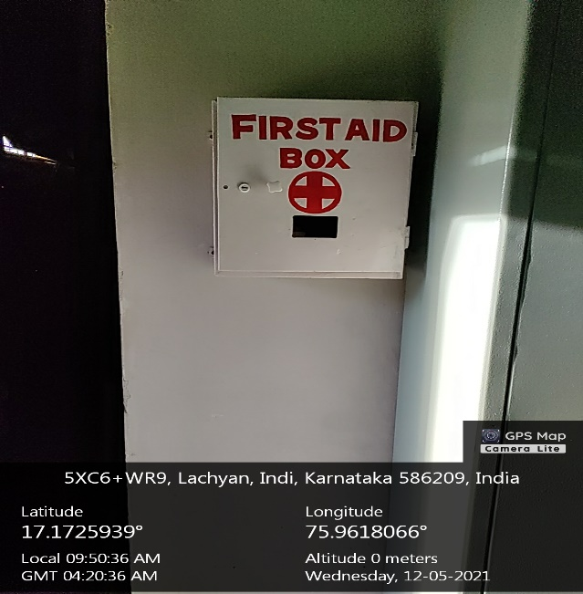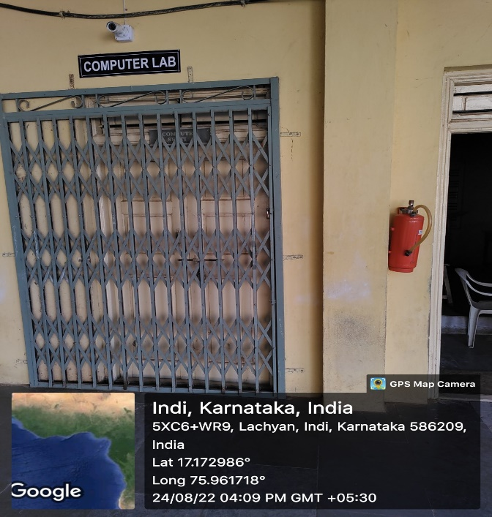

B. COUNSELLING: Mentor & Mentees system is effectively functioning in the college to counsel mentees. Mentors are allotted for every class to look personnel issues of mentees. Mentor is allotted for every 40 students to study their socio-economic background. Students grievance redressed committee is also actively functioning under WEC (Women Empowerment Cell) to council them.
SUGGESTION BOX
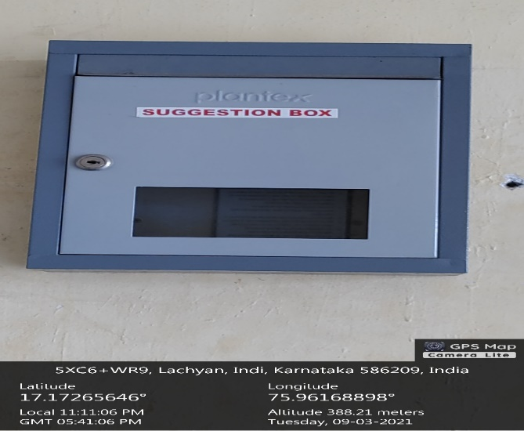
COUNCELLING FOR GIRLS
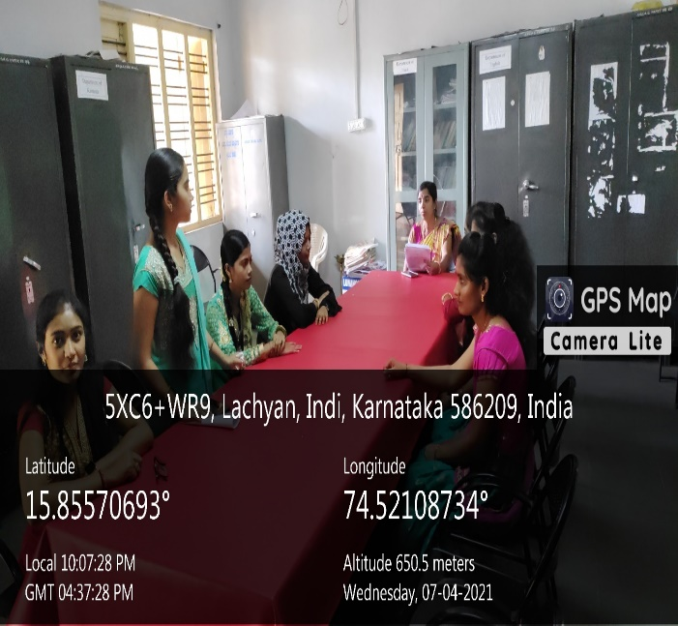
COUNCELLING FOR GIRLS
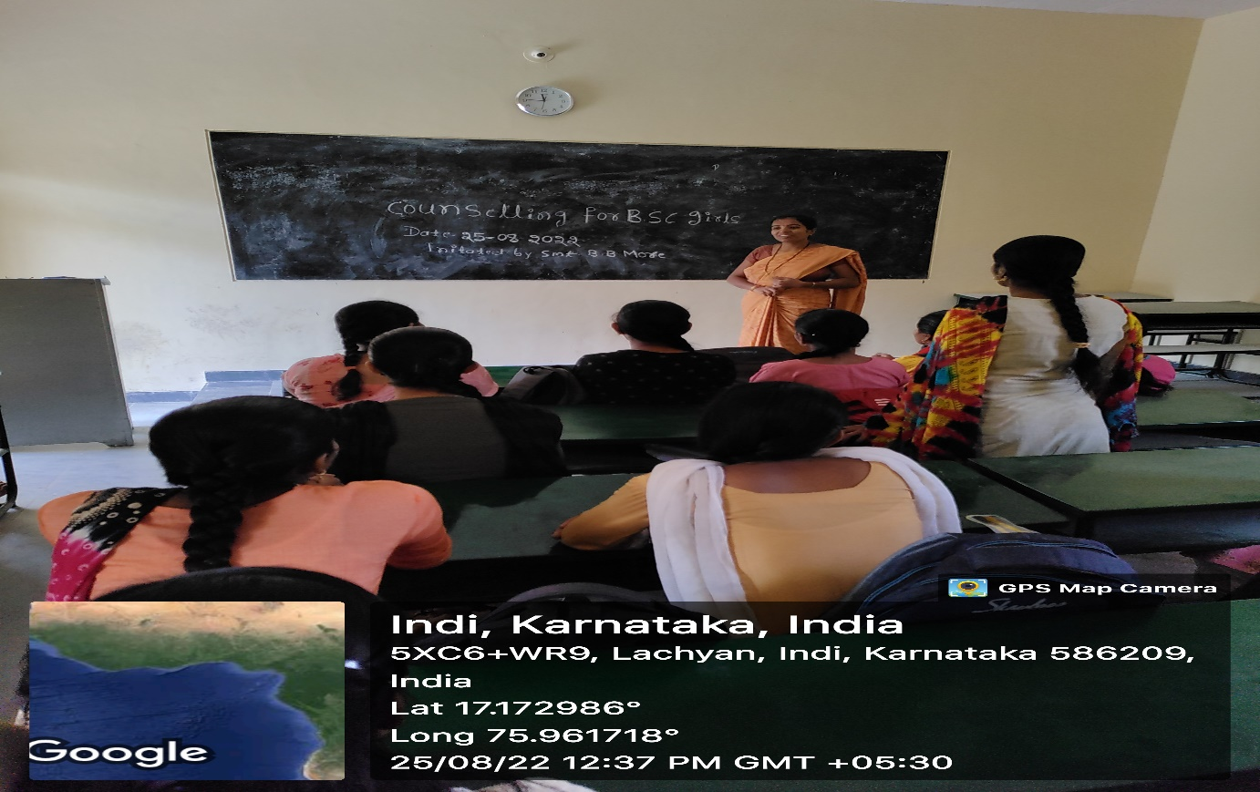

C. COMMON ROOM:
• Space for the visitors in the principal chamber as well as concerns Head of the department.
• Separate washrooms for girls and boys students of this institution.
• Separate washrooms for Principal in his/her chamber, washrooms also allotted for non-teaching in their respective rooms.
• Every department has exclusive washrooms for male and female faculty members
.COMMON ROOM FOR GIRLS
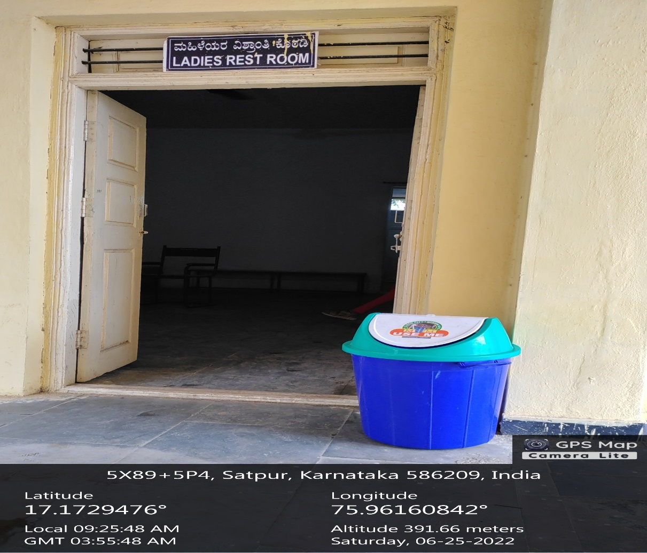

DRINKING WATER FACILITY FOR GIRLS IN COMMON ROOM
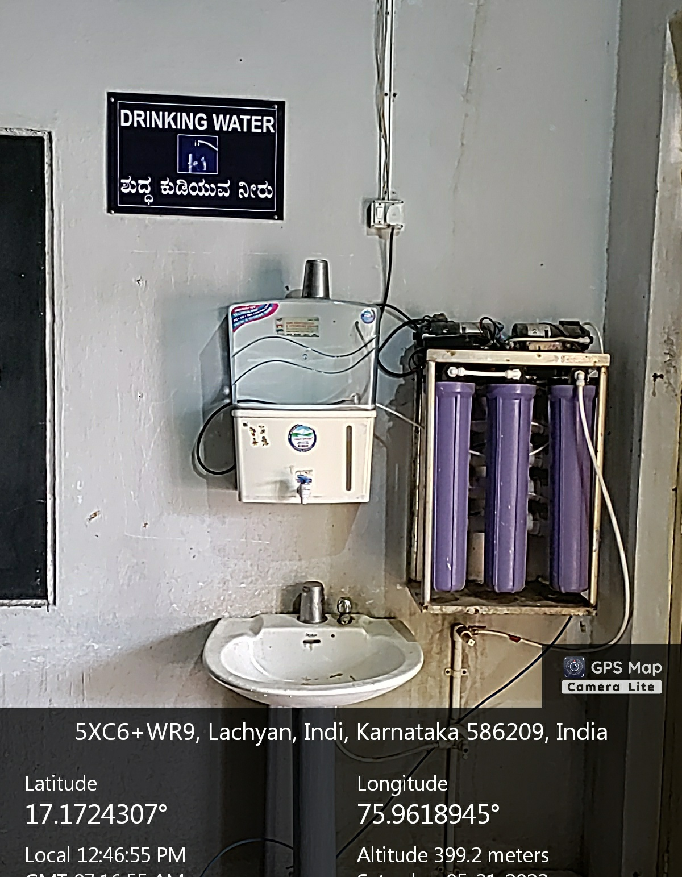
.COMMON ROOM FOR BOYS
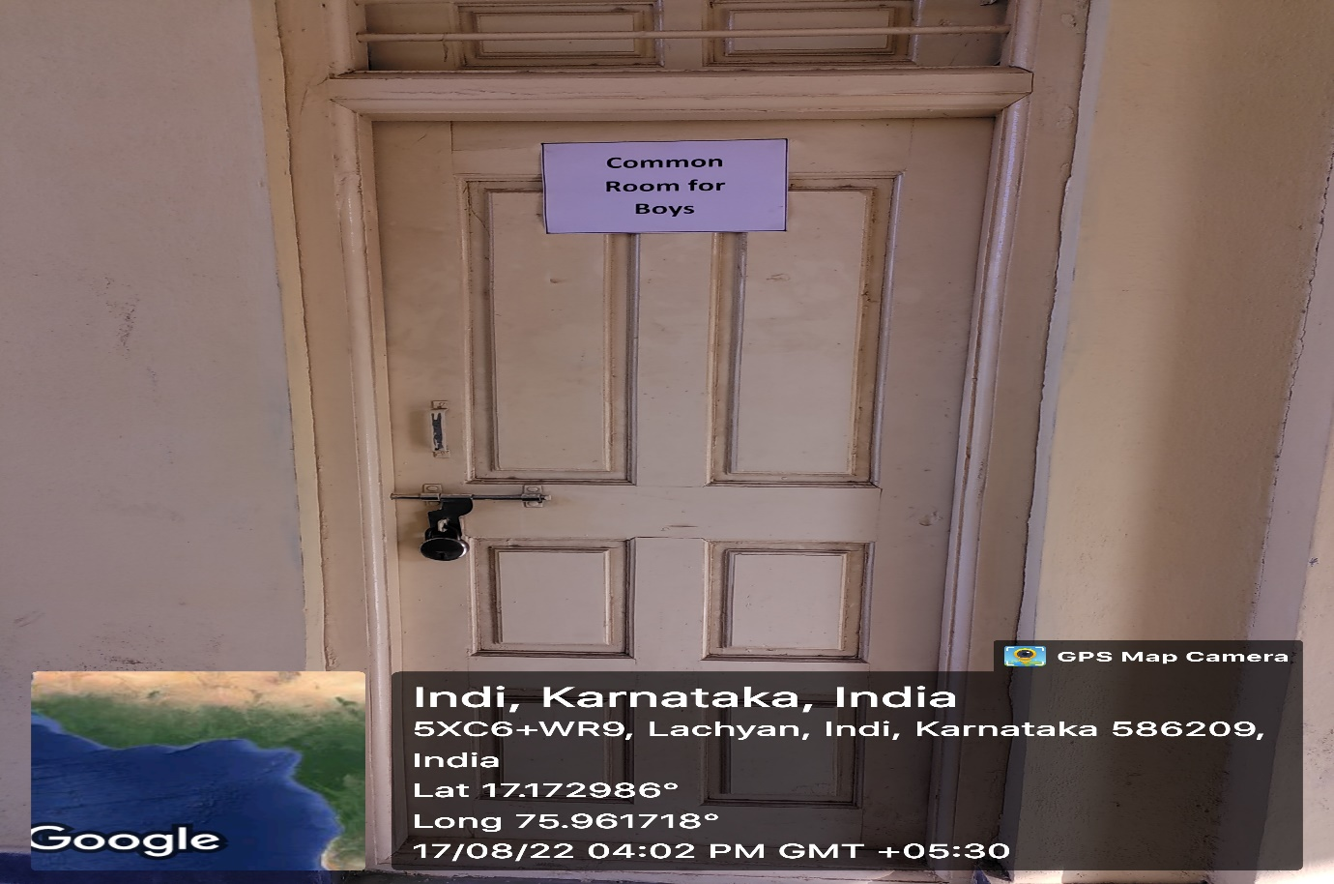

RELAVENT PHOTOS OF STUDENTS
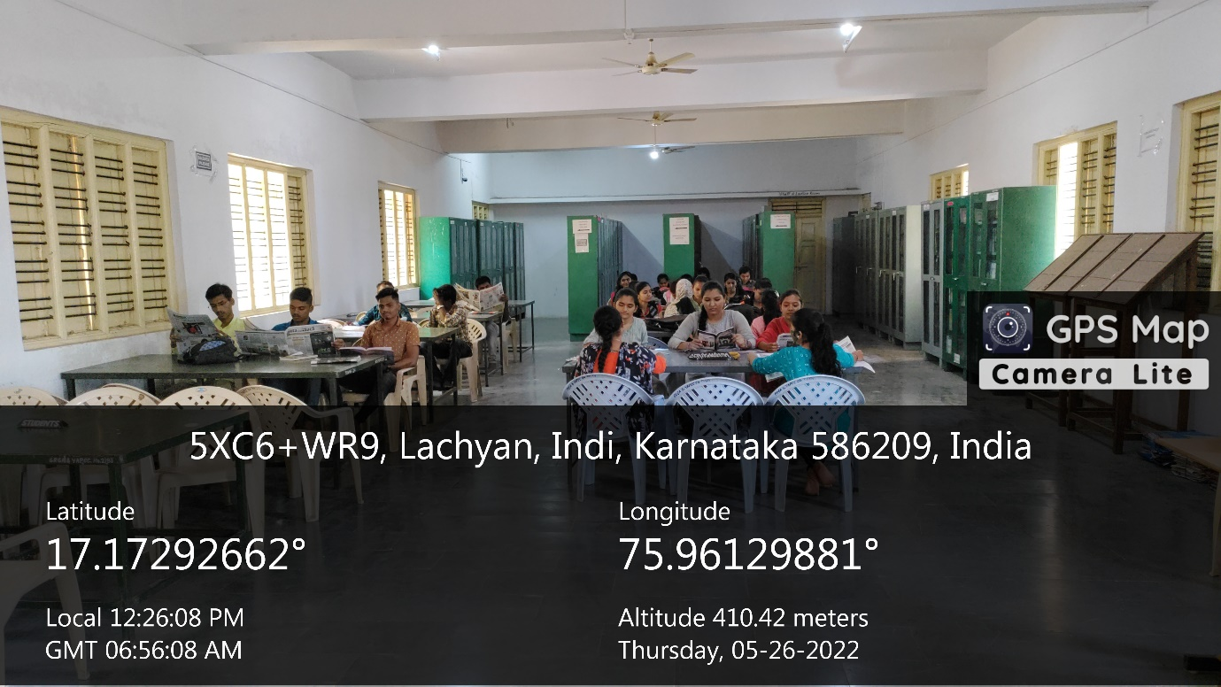
ID CARDS TO STUDENTS
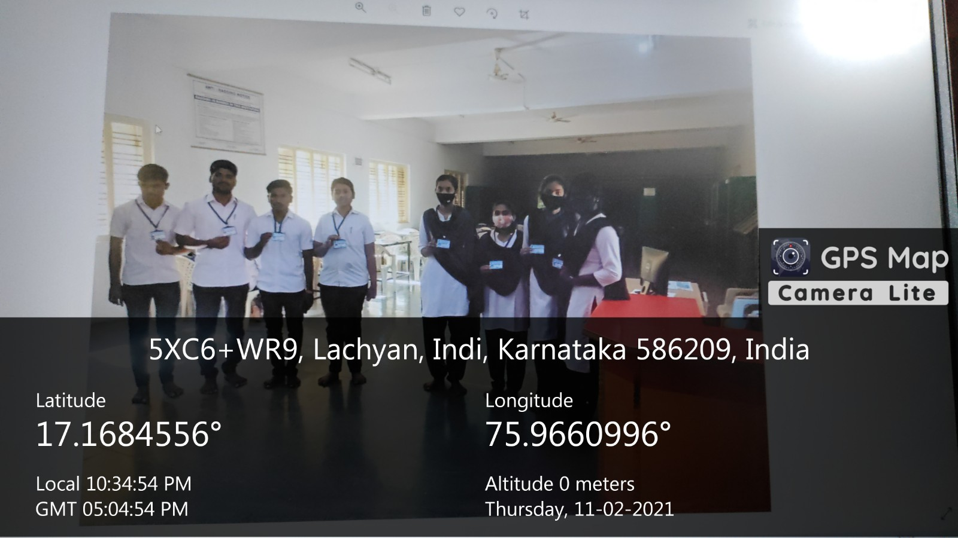

COMPUTER LAB
